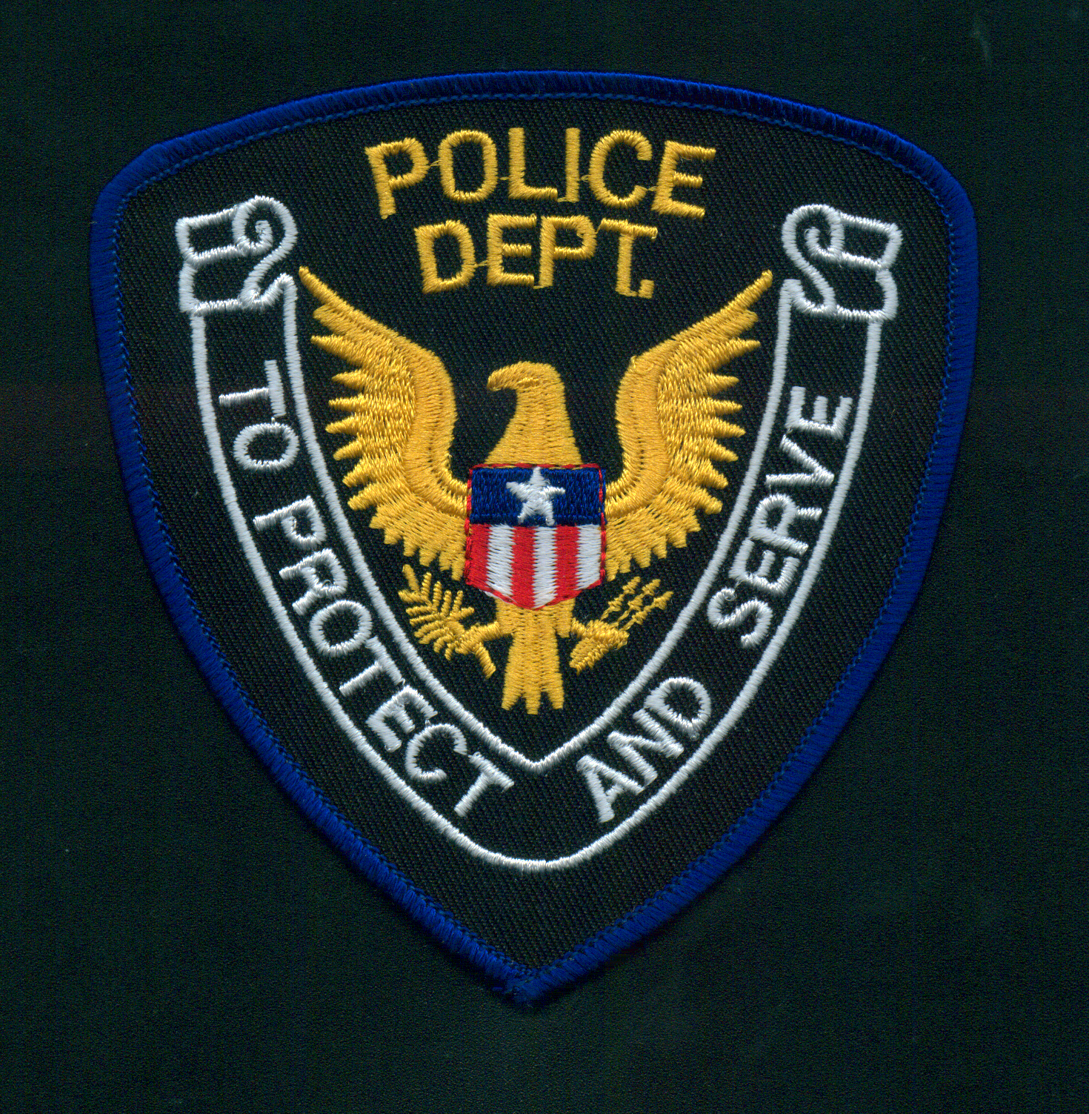
PAYNE POLICE DEPARTMENT EMERGENCY ALERTING AND NOTIFICATION SYSTEM
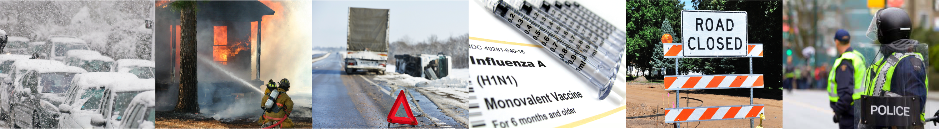

Dear Parents,

The PAYNE POLICE DEPARTMENT wants you and your children to be safe and informed during emergencies in our area, both during and after school. These may include public safety threats, dangerous weather, and traffic advisories. Information is key, and we strongly encourage you to sign up to receive text message alerts directly from the PAYNE POLICE DEPARTMENT.

Registering for alerts is easy — simply text your Zip Code to 888777 and you’ll be informed and instructed when necessary.
TEXT YOUR ZIP CODE TO 888777
TO SIGN UP FOR ALERTS

